**Johannes Brahms (1833-1897)**

Although most concert audiences think of Brahms principally as a composer of instrumental music – specifically the four symphonies, the concertos, chamber works and piano music – his output for the human voice formed by far and away the greatest part of his output. *A German Requiem*, written between 1863 and 1867, is certainly the best-known of all Brahms’ works for voices, but he also produced no less than 204 songs which were published in 32 volumes at various times between 1851 and 1896, along with several appearing in print posthumously.

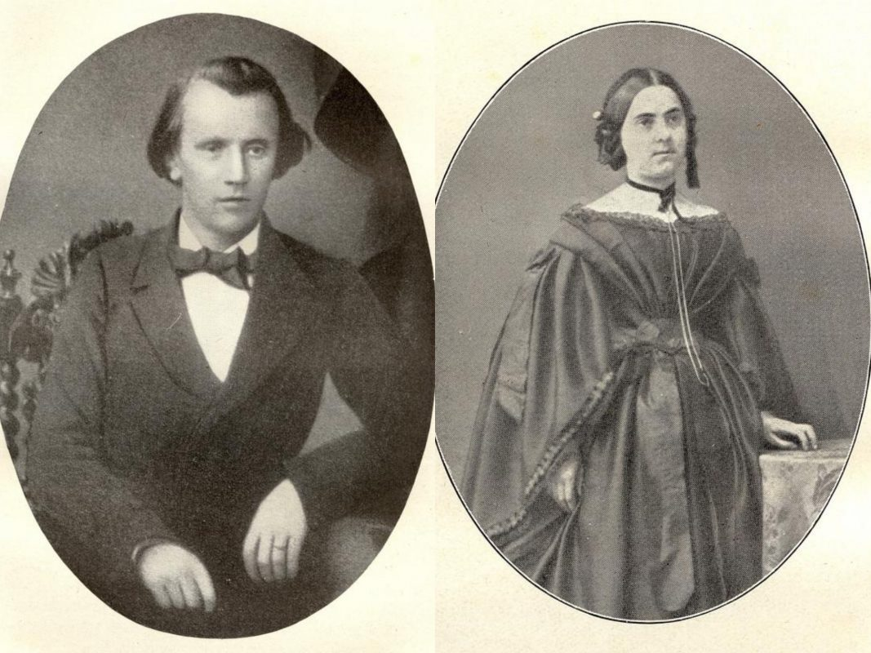

Brahms and the first singer in his life – Agathe von Siebold

In the words of Michael Quinn, “The voice was at the centre of Brahms's music. At its beginning and end, too. Of the first seven completed works he allowed into the public domain, three, significantly, were sets of songs. His last composition, the *Vier ernste Gesänge* (‘Four Serious Songs’), was also to be for voice. The preoccupation with song was ever present, always crucial, occasionally defining; the voice perpetually exploited and explored in more than 200 songs for solo voice, duet and solo quartet, and in a myriad of works for accompanied and *a cappella* choir. Suffice to say that the sense of the sung voice was instinctive and integral to Brahms's own sense of himself as both man and musician. ‘The ideal’, he once remarked, ‘is the folk-song’. He might well have added, ‘and the voice that creates it, the sublime’. More than the symphonies and the chamber music, it is the vocal music that most explicitly reveals the head and heart of a composer whose true, full and complex identity has been obscured by time and reputation. Where the autobiographical subtext of his instrumental music was frequently disguised, habitually denied, the provocation and purpose of the vocal music is often gloriously, unashamedly, immediately apparent. It is a repertoire that is honest, direct and intellectually unfettered. Unequal, too, it has to be said, in terms of quality. Yet, in a curious way, it is those obvious occasional weaknesses that give the whole its strength, make it so tantalizing, so endearing, so much more truthful and reliable an expression of the man who composed them. Punctuating the life and career as they do, the compositions for voice provide a revealing series of thumbnail portraits of Brahms that belie the lingering image of him as being ill-equipped or disinclined to deal with the complex reality of his own emotional responses to the people and events that impinged upon his life.”

**Lieder und Gesänge von August von Platen und G. F. Daumer, Op.32**

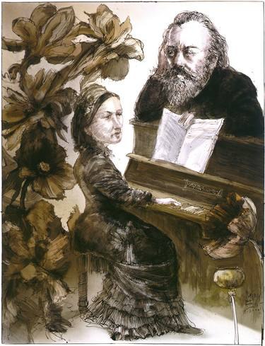

“Brahms Meets Clara Schumann”, Rainer Ehrt

Probably the best known of all Brahms’s many emotional hang-ups was his uncomfortable relationship with women. His thwarted love affairs were legendary. There were the famous infatuations with both Clara Schumann and her daughter, Julie, and the broken-off engagement to Agathe von Siebold. Then, in a letter to Clara (who had been urging him to settle down and find a wife) Brahms declared that he had met “a very pretty girl with whom, God knows, I might have made a fool of myself”.

That pretty young girl was Ottilie Hauer, a member of a choir Brahms was conducting. On Christmas Day 1863 Brahms made his way to Ottilie’s house determined to make a proposal of marriage only to arrive in the midst of celebrations announcing her betrothal to a certain Dr Edward EbnerIf. But if nothing else, that emotional set-back goaded Brahms to assess his life and work and finally grasp the nettle of creative doubt that had been undermining so much of his work up to that point. His immediate response was to start work on what was to be the largest single choral work he was ever to produce, *A German Requiem.* In his masterly biography of the composer Malcolm MacDonald suggests that the completion of *A German Requiem* in 1867 unlocked in Brahms an ability to “advance with total confidence into the great abstract form – especially the symphony and the string quartet – that had tantalized him for so long”. During the years that Brahms worked on it*,* he wrote a number of smaller pieces which might be seen as experiments in overcoming the issues he was faced with by the composition of *A German Requiem.*

One of these was a suite of nine songs to texts by August von Platen and Georg Friedrich Daumer which was published in 1867 as his Op.32. As MacDonald puts it, “Brahms’s difficulties and irresolution about future courses - in music as much as in life – are presented with exceptional clarity in [the songs of] Op.32”. He goes on to describe how the ordering of the texts suggests “a progressive emotional separation from a loved one, the accompanying depressions, frustration, and a sense of time wasted, and love that endures nevertheless, undimmed”. While the passage from darkness to light, from pessimism to optimism and from insecurity to comfort might be seen as a parallel to the course of *A German Requiem,* it is also difficult not to read an autobiographical sub-text into these nine songs. An early biographer, Max Kalbreck, suggests that Op.32 in effect, tells “a story from the heart”.

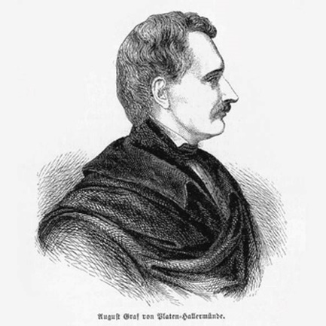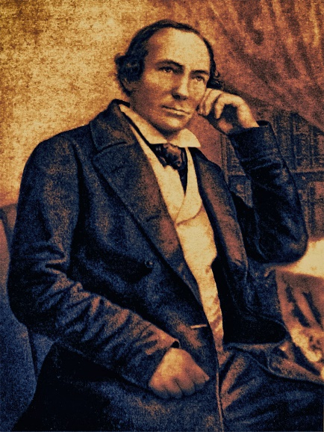

What of the two poets (pictured above) whose names Brahms, unusually, incorporated into the title page of the published edition? On the left we see August von Platen (1796-1835), a Bavarian soldier who, in 1818, abandoned the military in favour of literature, which he studied at the University of Würzburg, and devoted the rest of his life to writing poetry. Since drama was considered superior to poetry in the eyes of German philosophers of the 19th century, he faced much criticism for his work at home, so he moved to Italy in 1826 where he lived for the rest of his life. The picture on the right is of Georg Friedrich Daumer (1800-1875) who was very much more popular but correspondingly less gifted than Platen, yet Brahms seems to have been particularly attracted to his work. Daumer was a professor of Philosophy at the university in Nuremburg until forced to retire through ill-health in 1832. He spent the rest of his life writing literary works which propounded his strong anti-religious views and exhorted passion in love. In 1874 Brahms travelled to Würzburg to meet him. “He was a little dried-up old man. I soon perceived that he knew nothing either of me or my compositions, or anything at all of music. And when I pointed to his ardent, passionate verses, he gestured, with a tender wave of the hand, to a little old mother almost more withered than himself saying, ‘Ah, I have only loved the one; my wife’.”.

1. **Wie rafft' ich mich auf in der Nacht (“How I Roused Myself in the Night”)**

August von Platen

Wie rafft' ich mich auf in der Nacht, in der Nacht,

Und fühlte mich fürder gezogen,

Die Gassen verließ ich vom Wächter bewacht,

Durchwandelte sacht

In der Nacht, in der Nacht,

Das Tor mit dem gotischen Bogen.

Der Mühlbach rauschte durch felsigen Schacht,

Ich lehnte mich über die Brücke,

Tief unter mir nahm ich der Wogen in Acht,

Die wallten so sacht,

In der Nacht, in der Nacht,

Doch wallte nicht eine zurücke.

Es drehte sich oben, unzählig entfacht,

Melodischer Wandel der Sterne,

Mit ihnen der Mond in beruhigter Pracht,

Sie funkelten sacht

In der Nacht, in der Nacht,

Durch täuschend entlegene Ferne.

Oh, how I roused myself in the night, in the night,

And felt myself drawn farther;

I left the alleys,

guarded by the watchmen,

And wandered through quietly,

In the night, in the night,

The gate with the gothic arch.

The millbrook rushed through the rocky gorge,

I leaned over the bridge,

Observing far below me the waves,

Which rolled so quietly,

In the night, in the night,

Yet never did one roll back.

Overhead wanders the infinite, flickering,

melodic traffic of the stars,

With them, the moon in calm splendour;

They gleam quietly

In the night, in the night,

At a deceptively remote distance.

Ich blickte hinauf in der Nacht, in der Nacht,

Und blickte hinunter aufs neue:

O wehe, wie hast du die Tage verbracht,

Nun stille du sacht

In der Nacht, in der Nacht,

Im pochenden Herzen die Reue!

I gaze up into the night, in the night,

And gaze down again anew:

Alas, how have you spent the day!

Now, softly you try to still,

In the night, in the night,

the remorse of your pounding heart!

1. **Nicht mehr zu dir zu gehen (“To Visit You No Longer”)**

G. F. Daumer

Nicht mehr zu dir zu gehen

Beschloß ich und beschwor ich,

Und gehe jeden Abend,

Denn jede Kraft und jeden Halt verlor ich.

Ich möchte nicht mehr leben,

Möcht' augenblicks verderben,

Und möchte doch auch leben

Für dich, mit dir, und nimmer, nimmer sterben.

Ach, rede, sprich ein Wort nur,

Ein einziges, ein klares;

Gib Leben oder Tod mir,

Nur dein Gefühl enthülle mir, dein wahres!

To visit you no longer

Did I resolve and swear.

Yet I go to you each evening,

For all strength and resolve have I lost.

I long to live no longer,

I long to perish instantly

And yet I also long to live

For you, with you, and never, never die.

Ah, speak, say only one word,

A single word, a clear one;

Give me life or death,

Only reveal your true feelings to me!

1. **Ich schleich’ umher betrübt und stumm (“I creep about, sad and mute”)**

August von Platen

Ich schleich umher,

Betrübt und stumm,

Du fragst, o frage

Mich nicht, warum?

Das Herz erschüttert

So manche Pein!

Und könnt' ich je

Zu düster sein?

Der Baum verdorrt,

Der Duft vergeht,

Die Blätter liegen

So gelb im Beet,

Es stürmt ein Schauer

Mit Macht herein,

Und könnt ich je

Zu düster sein?

I creep about,

sad and mute.

You ask, o ask

me not, why?

My heart shakes

with so much pain!

Could I ever be

too gloomy?

The tree withers and dies,

the breeze fades away,

The leaves lie

so yellow in the yard,

A shower storms

with might toward us;

Could I ever be

too gloomy?

1. **Der Strom, der neben mir verrauschte (“The stream that rushed past”)**

August von Platen

Der Strom, der neben mir verrauschte, wo ist er nun?

Der Vogel, dessen Lied ich lauschte, wo ist er nun?

Wo ist die Rose, die die Freundin am Herzen trug?

Und jener Kuß, der mich berauschte, wo ist er nun?

Und jener Mensch, der ich gewesen, und den ich längst

Mit einem andern ich vertauschte, wo ist er nun?

The stream that rolled past me, where is it now?

The bird to whose song I listened, where is it now?

Where is the rose that my sweetheart wore on her heart?

And that kiss that intoxicated me, where is it now?

And that man that I once was, whom long ago I exchanged

for another self - where is he now?

1. **Wehe, so willst du mich wieder (“Alas, so you would again**”)

August von Platen

Wehe, so willst du mich wieder,

Hemmende Fessel, umfangen?

Auf, und hinaus in die Luft!

Ströme der Seele Verlangen,

Ström' es in brausende Lieder,

Saugend ätherischen Duft!

Strebe dem Wind nur entgegen

Daß er die Wange dir kühle,

Grüße den Himmel mit Lust!

Werden sich bange Gefühle

Im Unermeßlichen regen?

Atme den Feind aus der Brust!

Alas, so you would again,

You hindering shackles, imprison me?

Up and out into the air!

Out streams the longing of the soul,

flowing out in clamorous songs,

Inhaling ethereal fragrances!

Struggle against the wind,

That it might cool your cheeks,

Greet the heavens with joy!

Will timid emotions

Move you as you gaze upon the Infinite?

Exhale the foe from out of your breast!

1. **Du sprichst, daß ich mich täuschte (“You say that I deluded myself”)**

August von Platen

Du sprichst, daß ich mich täuschte,

Beschworst es hoch und hehr,

Ich weiß ja doch, du liebtest,

Allein du liebst nicht mehr!

Dein schönes Auge brannte,

Die Küsse brannten sehr,

Du liebtest mich, bekenn es,

Allein du liebst nicht mehr!

Ich zähle nicht auf neue,

Getreue Wiederkehr;

Gesteh nur, daß du liebtest,

Und liebe mich nicht mehr!

You say that I deluded myself,

You swear it imposingly;

I know however, that you loved me,

Only now you love me no more.

Your lovely eyes glowed bright,

Your kisses burned greatly;

You loved me, confess it,

Only now you love me no more!

I count on nothing new,

No return to faithfulness;

Just admit that you did love,

And now love me no more!

1. **Bitteres zu sagen denkst du (“You are thinking of something bitter”).**

G. F. Daumer

Bitteres zu sagen denkst du;

Aber nun und nimmer kränkst du,

Ob du noch so böse bist.

Deine herben Redetaten

Scheitern an korall'ner Klippe,

Werden all zu reinen Gnaden,

Denn sie müssen, um zu schaden,

Schiffen über eine Lippe,

Die die Süße selber ist.

You are thinking of something bitter to say

But never might you cause offence,

Although you are so angry.

Your sharp speech

Founders on coral rocks,

And becomes pure grace,

For it must, in order to cause shame,

Sail over a pair of lips

Which is Sweetness itself.

1. **So stehn wir, ich und meine Weide (“So we stand”).**

G F Daumer

So stehn wir, ich und meine Weide,

So leider miteinander beide.

Nie kann ich ihr was tun zu Liebe,

Nie kann sie mir was tun zu Leide.

Sie kränket es, wenn ich die Stirn ihr

Mit einem Diadem bekleide;

Ich danke selbst, wie für ein Lächeln

Der Huld, für ihre Zornbescheide.

So we stand, I and my mistress,

So unfortunate with each other!

Never can I do anything to please her;

Never can she do anything to pain me.

It hurts her feelings when upon her brow

I adorn her with a diadem;

I myself am thankful, as much for a smile

of favour, as for a furious reply.

1. **Wie bist du, meine Königin (“How blissful you are, my queen”).**

G F Daumer

Wie bist du, meine Königin,

Durch sanfte Güte wonnevoll!

Du lächle nur, Lenzdüfte wehn

Durch mein Gemüte, wonnevoll!

Frisch aufgeblühter Rosen Glanz,

Vergleich ich ihn dem deinigen?

Ach, über alles, was da blüht,

Ist deine Blüte wonnevoll!

Durch tote Wüsten wandle hin,

Und grüne Schatten breiten sich,

Ob fürchterliche Schwüle dort

Ohn Ende brüte, wonnevoll!

Laß mich vergehn in deinem Arm!

Es ist ihm ja selbst der Tod,

Ob auch die herbste Todesqual

Die Brust durchwüte, wonnevoll!

How blissful you are, my queen,

When you are gentle and good!

Merely smile, and spring fragrance wafts

Through my spirit blissfully!

The brightness of freshly blooming roses,

Shall I compare it to yours?

Ah, soaring over all that blooms

Is your bloom, blissful!

Wander through dead wastelands,

And green shadows will be spreading,

Even if fearful sultriness

Broods there without end... blissfully!

Let me die in your arms!

It is in them that Death itself,

Even if the sharpest pain

Rages in my breast... is blissful!

[English translations © Emily Ezust - from the LiederNet Archive <https://www.lieder.net/>]

**Lieder und Gesänge, Opus 71**

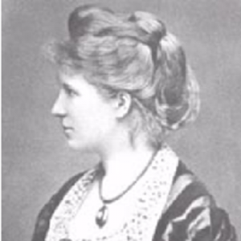

Elisabet von Herzogenberg

As if on the rebound from his disastrous affair with Ottilie Hauer, Brahms promptly transferred his affections to one of his piano pupils, Elisabet von Stockhausen, who was then aged 16. Contemporary reports describe her as “not really beautiful but better than beautiful, at once dazzling and bewitching; the fairest of skins, fine-spun, wavy golden hair, curious arresting greenish-brown eyes. With her, sunshine came in at the door”. In his biography of the composer, Jan Swafford writes; “Elisabet inflicted on Brahms a kind of trembling awe. Especially just after his recent brush with the altar, he was terrified of touching her, of falling in love with her”, so to avoid any risk of getting too emotionally involved and then suffering the same sort of disappointment he had suffered with Ottilie, Brahms sent her away. Two years later she married the composer Heinrich von Herzogenberg, and it was only in the mid-1870s that they met each other again. As Swafford writes, “Elisabet von Herzogenberg re-entered Brahms’s life at exactly the time he needed her”, and their relationship flourished. By 1877 it had grown into a full-blown infatuation on Brahms’s behalf (for the next 10 years he kept a photo of her on his desk as he composed) and seems to have triggered an outburst of song-writing.

In early 1877 Brahms had stayed with Elisabet and her husband, and in March of that year wrote a letter to her in which he confessed: “It was so delightful staying with you. The memory is still warm, and I feel I want to keep it snugly buttoned up for a long time. But these things are easier to express in music…later I shall choose the most beautiful key and the most beautiful poem to write the continuation [of this letter]”. As good as his word, the following month he wrote 18 songs which, added to four written in 1875 and 1876, were published in four volumes as his Opp.69, 70, 71 and 72. More than one commentator has identified elements in these songs which express Brahms’s feelings for Elisabet, but taking a less emotionally-charged approach, Inge Van Rij points out that “The various aspects of thwarted love affairs were staple fare in Brahms’s Lieder – indeed, in Lieder generally – and require no specific autobiographical explanation”. In this broadcast Alan Bennett performs the *Funf Gesänge für eine Singstimme mit Begleitung des Pianoforte* (“5 Songs for solo voice accompanied by piano”)which form the third published set of that year’s outpouring of songs.

**Es liebt sich so lieblich im Lenze (“Love is so Lovely in Spring“)**. Heinrich Heine.

Die Wellen blinken und fließen dahin,

Es liebt sich so lieblich im Lenze!

Am Flusse sitzet die Schäferin

Und windet die zärtlichsten Kränze.

Das knospet und quillt und duftet und blüht,

es liebt sich so lieblich im Lenze!

Die Schäferin seufzt aus tiefer Brust:

»Wem geb' ich meine Kränze?«

Ein Reiter reitet den Fluß entlang,

er grüßet so blühenden Mutes,

die Schäferin schaut ihm nach so bang,

fern flattert die Feder des Hutes.

Sie weint und wirft in den gleitenden Fluß

die schönen Blumenkränze.

Die Nachtigall singt von Lieb' und Kuß,

es liebt sich so lieblich im Lenze!

The waves flash and flow in;

Love is so lovely in Spring!

By the river the shepherdess sits

And weaves delicate crowns of wreaths.

The budding, the streaming, the wafting, and blossoming -

Love is so lovely in spring!

The shepherdess sighs from deep in her bosom:

"To whom shall I give my wreaths?"

A horseman rides along the river:

he greets her with radiant cheer,

the shepherdess gazes at him shyly,

and far in the distance the feather flutters in his cap.

She weeps and throws into the gliding river

those lovely wreaths of flowers.

The nightingale sings of love and kisses;

Love is so lovely in the spring!

1. **An den Mond (“To the Moon”).**

Karl Joseph Simrock.

Silbermond mit bleichen Strahlen

pflegst du Wald und Feld zu malen,

gibst den Bergen, gibst den Talen

der Empfindung Seufzer ein.

Sei Vertrauter meiner Schmerzen,

Segler in der Lüfte See:

Sag’ ihr, die ich trag’ im Herzen,

wie mich tötet Liebesweh.

Sag’ ihr, über tausend Meilen

sehne sich mein Herz nach ihr.

»Keine Ferne kann es heilen,

nur ein holder Blick von dir.«

Sag’ ihr, daß zu Tod getroffen

diese Hülle bald zerfällt;

nur ein schmeichlerisches Hoffen

sei’s, das sie zusammenhält.

Silver moon with pale rays,

you often paint the forest and field;

you give the mountains, you give the valleys

a sigh of feeling.

Be the confidant of my sorrows,

sailor on the sea of the air:

Tell her, whom I carry in my heart,

how yearning for love is killing me.

Tell her that over a thousand miles

my heart pines for her.

"No distance can heal it,

only a loving glance from you."

Tell her that I have been struck mortally

and my body soon shall fall;

only a flattering hope

keeps me together.

1. **Geheimnis (“Secret”).**

Karl Candidus.

O Frühlingsabenddämmerung!

O laues, lindes Weh’n,

Ihr Blütenbäume, sprecht, was tut

ihr so zusammensteh’n?

Vertraut ihr das Geheimnis euch

Von uns’rer Liebe süß?

Was flüstert ihr einander zu

Von uns’rer Liebe süß?

O spring's evening twilight!

O mild, gently breezes,

You blossoming trees, speak; what are you doing,

standing so close together?

Do you confide to one another

the secret of our sweet love?

What do you whisper to one another

about our sweet love?

1. **Willst du, daß ich geh’? (“Do You Wish Me to Go?”).**

Karl Lemcke.

Auf der Heide weht der Wind -

Herzig Kind, herzig Kind -

Willst du, daß trotz Sturm und Graus

In die Nacht ich muß hinaus -

Willst du, daß ich geh’?

Auf der Heid’ zu Bergeshöh’

Treibt der Schnee, treibt der Schnee;

Feget Straßen, Schlucht und Teich

Mit den weißen Flügeln gleich.

Willst du, daß ich geh’?

Horch, wie klingt’s herauf vom See

Wild und weh, wild und weh!

An den Weiden sitzt die Fei

Und mein Weg geht dort vorbei -

Willst du, daß ich geh’?

Wie ist’s hier in deinem Arm

Traut und warm, traut und warm;

Ach, wie oft hab’ ich gedacht:

So bei dir nur eine Nacht -

Willst du, daß ich geh’?

On the heath blows the wind -

Sweet child, sweet child -

do you wish me, despite the storm and horror,

to go out into the night -

do you wish me to go?

On the heath at the top of the mountain

Piles the snow, piles the snow;

It sweeps the street, the gorge and pool alike

with white wings.

Do you wish me to go?

Hark! the sound of the sea

is wild and woeful, wild and woeful!

By the willows sits an evil sprite

and my path goes past that place -

Do you wish me to go?

For here in your arms,

how cosy and warm, cosy and warm;

Ah, how often have I thought:

if only I could have just one night with you...

Do you wish me to go?

1. **Minnelied (“Love Song”).**

Ludwig Heinrich Christoph Hölty.

Holder klingt der Vogelsang,

Wenn die Engelreine,

Die mein Jünglingsherz bezwang

Wandelt durch die Haine.

Röter blühen Tal und Au,

Grüner wird der Wasen,

Wo die Finger meiner Frau

Maienblumen lasen.

Ohne sie ist alles tot,

Welk sind Blüt’ und Kräuter;

Und kein Frühlingsabendrot

Dünkt mir schön und heiter.

Traute, minnigliche Frau,

Wollest nimmer fliehen;

Daß mein Herz, gleich dieser Au,

Mög’ in Wonne blühen!

Delightfully sound the birdsongs

when the pure angel

who conquered my young heart

wanders through the wood.

Redder bloom the valleys and meadows,

Greener becomes the grass

where the fingers of my lady

Are picking little mayflowers.

Without her, everything is dead.

Blossoms and herbs are wilted;

and no spring sunset

would seem to me as fair and fine.

Darling, lovely woman,

Never wish to flee;

that my heart, as well as this meadow,

might bloom in joy!

[English translations © Emily Ezust - from the LiederNet Archive https://www.lieder.net/]